**DEEP2NEURON TECH ACADEMY-INTERNSHIP 2023**

**DAY 7 -25.06.2023**

On this day, I started with a new architecture and started executing. I selected Resnet50 and followed the same steps as I done for the previous model. I maked some changes in the code respective to this model. The same epochs took some time for running. This time I worked on the confusion matrix and got it more clear than VGG architecture.

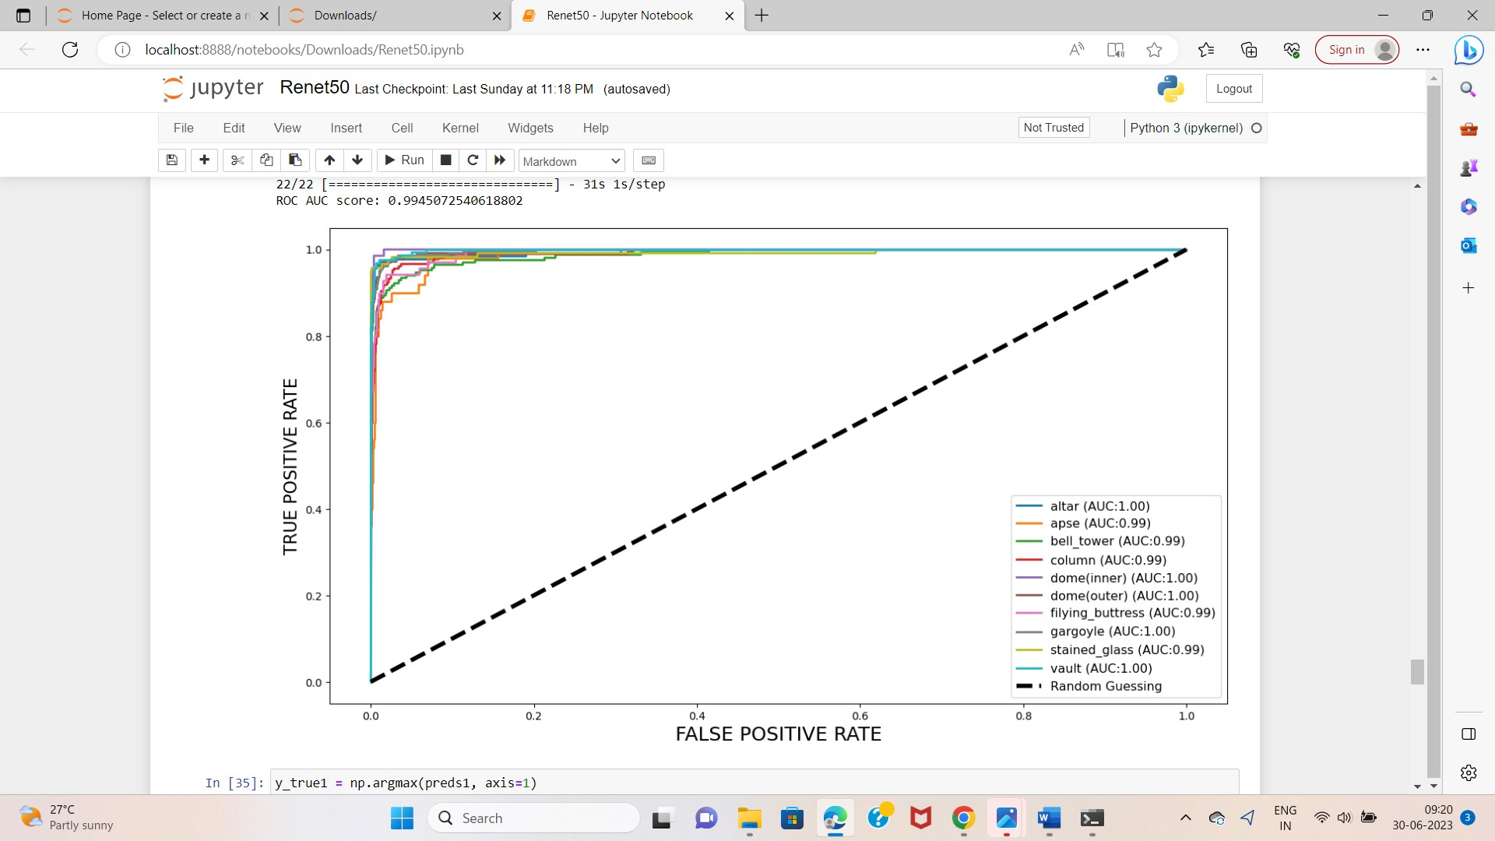

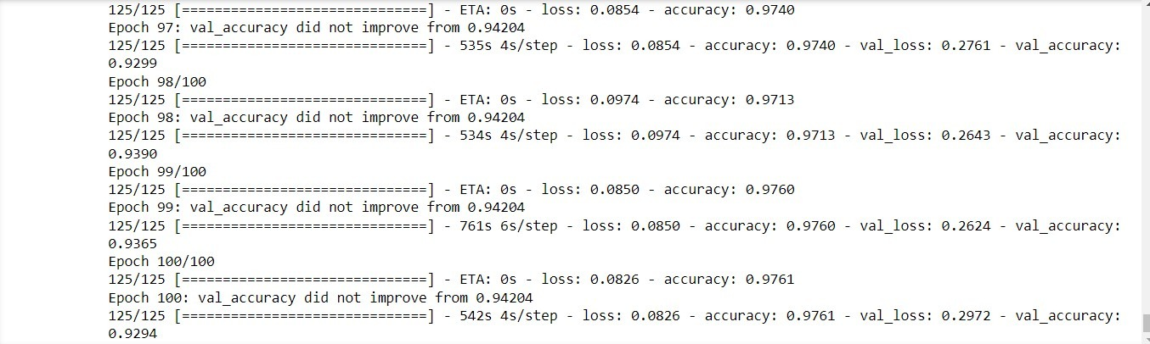

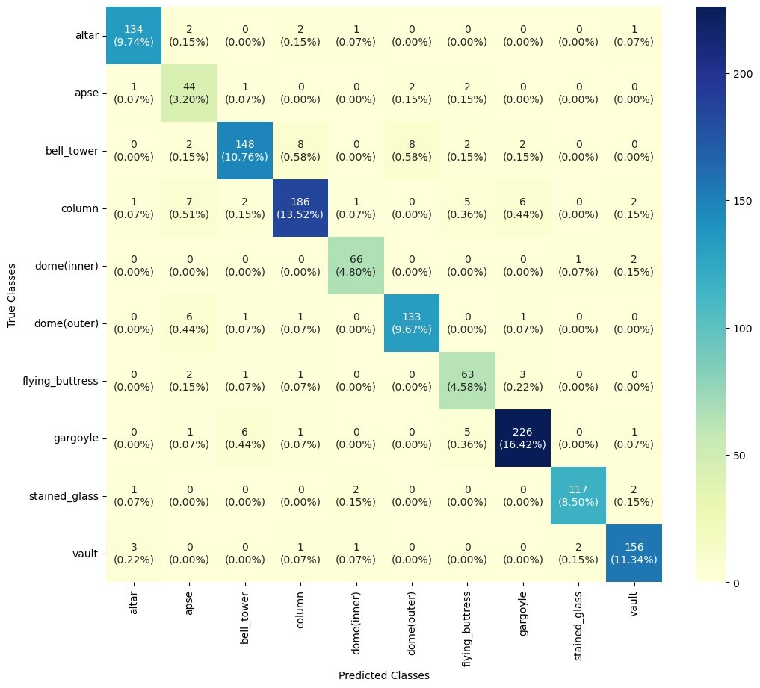

Model : Resnet

Epoch : 100

Batch_size:64

LR:0.001

Accuracy: 0.925145

Precision: 0.905909

Recall: 0.924433

F1 score: 0.913610

**LEARNINGS :**

* Learnt more on model training.
* Built the confusion matrix more accurate in accordance with previous model.
* Got an entire overview on CNN model.